COMPLETE SPECIFICATION

TITLE OF THE INVENTION
AutoRoller is a retrofit, dust-sensor-triggered cleaning device that clips onto existing solar panels to autonomously wipe them clean using power drawn from the panel itself.

ABSTRACT OF THE INVENTION
The present invention relates to a retrofit apparatus for cleaning the exposed surface of a solar photovoltaic panel without depending on a fixed cleaning schedule or on grid power. A dust and soiling sensor mounted on or near the panel surface continuously monitors surface obscuration and issues a cleaning command only when accumulated dust crosses a threshold that would otherwise cause a measurable drop in panel output.
On receiving this command, a carriage carrying a dry microfiber roller or wiper traverses the panel along a guide rail, physically displacing loose dust and particulate matter from the glazing without the use of water. The apparatus draws its operating power from a small buffer battery that is itself charged through a pin-clip tap connected across the panel's own output during peak sunlight hours, so that the timing of a cleaning cycle is decoupled from the panel's instantaneous power output, which is typically depressed precisely when cleaning is most needed.
The apparatus is dimensioned for a single standard residential panel footprint and is designed as the first, self-contained cleaning module of a larger modular family, leaving provision for a later, separately installable optical enhancement attachment without altering the cleaning module itself. The invention improves the net energy yield of an installed solar panel over its operating life, reduces manual maintenance labour, and lowers the water consumption ordinarily associated with wet panel-cleaning practice.

PREAMBLE TO THE DESCRIPTION
The following specification particularly describes the invention and the manner in which it is to be performed.

DESCRIPTION:
This invention relates generally to the field of renewable energy infrastructure maintenance, and more particularly to an automated, retrofittable apparatus and associated method for the periodic dry cleaning of solar photovoltaic panel surfaces, the activation of which is governed by a real-time soiling sensor rather than by a preset time interval, and the operation of which is powered by energy harvested from the panel it services.
Solar photovoltaic panels accumulate dust and other particulate matter during outdoor exposure, which scatters and absorbs incident sunlight and is a well-documented cause of energy yield loss, particularly in dry or high-pollen environments. Existing solutions are either manual, and thus labour-intensive and hazard-prone, or automated on a fixed time schedule, and thus insensitive to the panel's actual soiling condition; the latter category also frequently relies on water, a scarce resource in high-irradiance regions, or draws power directly from the panel's own instantaneous output, which is depressed precisely when the panel is dirtiest and cleaning is most needed.
There exists, therefore, an unmet need for a solar panel cleaning apparatus that activates only when the measured soiling condition warrants it, operates without water, draws on a power supply independent of the panel's instantaneous output, and is compact enough for retrofit onto a single residential panel.
The principal objects of the present invention are set out below:
- To provide an automated solar panel cleaning apparatus that is triggered by a real-time dust or soiling sensor rather than by a fixed time schedule.
- To provide such an apparatus that performs cleaning using a dry microfiber wiping element, thereby eliminating the water consumption associated with conventional wet cleaning systems.
- To provide such an apparatus with a self-contained power supply comprising a buffer battery charged from the host panel's own output during periods of peak irradiance, such that the timing of a cleaning cycle is decoupled from the panel's instantaneous output and is not compromised when the panel is soiled.
- To provide an apparatus that is retrofittable to a single standard residential solar panel without modification of the panel itself or the need for a separate external power connection.
- To provide an apparatus architecture that accommodates future modular enhancement, including a separately installable optical enhancement attachment, without requiring redesign of the base cleaning module.
- To reduce the labour, water consumption, and safety risk associated with manual or fixed-schedule solar panel maintenance.
The present invention provides a solar panel cleaning apparatus comprising, in combination: a pin-clip power tap drawing current from the host panel during peak sunlight; a buffer battery storing this energy independently of the panel's instantaneous output; a soiling sensor that generates a trigger signal once dust accumulation crosses a predetermined threshold; a control unit that initiates a cleaning cycle, using battery power, in response to that signal; and a cleaning carriage carrying a dry microfiber wiping element along a guide rail spanning the panel, driven by a motor under the control unit's command, so as to displace accumulated particulate matter without the use of water. Because activation is demand-driven and power is drawn from the buffer battery rather than the panel's live output, a cleaning cycle can be executed whenever it is needed, including when the panel's own output is depressed by the very soiling to be removed.
An embodiment of the invention will now be described with reference to a single standard residential solar panel, it being understood that the apparatus is scalable to other panel dimensions without departure from the underlying inventive concept.
A guide rail assembly is fixed along two opposite edges of the host panel frame, along which a cleaning carriage travels. The carriage carries a roller or blade faced with dry microfiber, driven by a small electric motor under the command of a control unit. A soiling sensor, comprising an optical or capacitive dust-detection element mounted on or adjacent to the panel surface, samples the degree of surface obscuration and reports it to the control unit; when the measured soiling crosses a predetermined threshold, the control unit initiates a cleaning cycle, during which the carriage traverses the guide rail, wiping accumulated dust from the panel.
Power for the sensor, control unit, and drive motor is drawn not directly from the panel's instantaneous output but from a buffer battery, which is itself charged through a pin-clip tap connected across the panel's output terminals during periods of peak sunlight. Because the buffer battery, and not the live panel output, supplies each cleaning cycle, the apparatus remains capable of cleaning even when the panel's own output is depressed by the soiling it is meant to address.
In the embodiment described, the apparatus is configured as a cleaning module only, dimensioned for a single residential panel footprint, with a modular mounting provision that allows a separately developed optical enhancement attachment to be installed later without modifying the cleaning module, guide rail, sensor, or power supply. A person skilled in the art will appreciate that the specific sensor type, drive mechanism, and battery capacity may be varied according to panel size and installation conditions without departing from the scope of the invention as claimed.

CLAIM
I/We claim:
- An automated solar panel cleaning apparatus comprising: a soiling sensor configured to detect accumulation of dust or particulate matter on a surface of a solar panel and to generate a trigger signal when detected soiling exceeds a predetermined threshold; a power tap configured to draw current from the solar panel during periods of peak sunlight; a buffer battery electrically connected to the power tap and configured to store energy independently of the instantaneous output of the solar panel; a control unit responsive to the trigger signal and configured to initiate a cleaning cycle using power drawn from the buffer battery; and a cleaning carriage comprising a dry wiping element mounted for travel along a guide rail spanning the solar panel, driven by a motor under command of the control unit, such that the wiping element traverses the surface of the solar panel and displaces accumulated particulate matter therefrom without the use of water.
- The apparatus as claimed in claim 1, wherein the power tap comprises a pin-clip connector arranged to be clipped across an output terminal of the solar panel.
- The apparatus as claimed in claim 1, wherein the dry wiping element comprises a microfiber roller or blade mounted on the cleaning carriage.
- The apparatus as claimed in claim 1, wherein the soiling sensor comprises an optical or capacitive dust-detection element mounted on or adjacent to the surface of the solar panel.
- The apparatus as claimed in claim 1, wherein the control unit is configured to initiate the cleaning cycle exclusively in response to the trigger signal generated by the soiling sensor, and not according to a fixed time schedule.
- The apparatus as claimed in claim 1, wherein the guide rail assembly and cleaning carriage are dimensioned for retrofit installation on a single standard residential solar panel.
- The apparatus as claimed in claim 1, further comprising a modular mounting provision configured to receive a separately installable optical enhancement attachment without modification of the cleaning carriage, the guide rail assembly, the soiling sensor, or the power supply.
- A method of cleaning a solar photovoltaic panel, comprising: monitoring, by a soiling sensor, the accumulation of dust or particulate matter on a surface of the panel; generating a trigger signal when the monitored accumulation exceeds a predetermined threshold; drawing power, in response to the trigger signal, from a buffer battery that is charged from a power tap connected to the panel during periods of peak sunlight and is thereby maintained independent of the instantaneous output of the panel; and driving a carriage carrying a dry wiping element along a guide rail spanning the panel, so as to displace the accumulated particulate matter from the surface of the panel without the use of water.
- The method as claimed in claim 8, wherein the step of drawing power from the buffer battery permits execution of the cleaning cycle at a time when the instantaneous output of the panel is reduced on account of the accumulated particulate matter.

Dated this _____ day of __________, 2026.
Signature: _______________________
Name of Applicant……..et.al

COMPLETE SPECIFICATION
The Abstract of the Invention, the Preamble to the Description, the Description (comprising the Field of the Invention, Background of the Invention and Prior Art, Objects of the Invention, Summary of the Invention, and Detailed Description of the Invention), and the Claim set out above, taken together, constitute the Complete Specification of the invention titled “AN AUTOMATED, DEMAND-TRIGGERED SOLAR PHOTOVOLTAIC PANEL CLEANING APPARATUS WITH BUFFERED SOLAR-DERIVED POWER SUPPLY (AUTOROLLER)”, filed in accordance with Section 10 of the Patents Act, 1970 and Rule 13 of the Patents Rules, 2003.
AutoRoller is a retrofit, dust-sensor-triggered cleaning device that clips onto existing solar panels to autonomously wipe them clean using power drawn from the panel itself.

- Power Supply (Pin-Clip Solar Tap + Buffer Battery)
- Microcontroller/ Control Unit (ESP32-based)
- Soiling/Dust Sensor (Optical or Capacitive Impurity Detection)
- Guide Rail Assembly (Panel-Span Traversal Track)
- Cleaning Carriage (Motor-Driven Dry Microfiber Roller/Wiper)
- Drive Motor
- Sensor-to-Control Communication Interface (Trigger Signal Link
- Modular Upgrade Port (for future TIR Enhancer Attachment)

AutoRoller is a retrofit, dust-sensor-triggered cleaning device that clips onto existing solar panels to autonomously wipe them clean using power drawn from the panel itself.
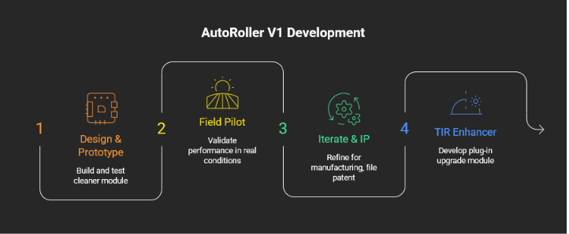
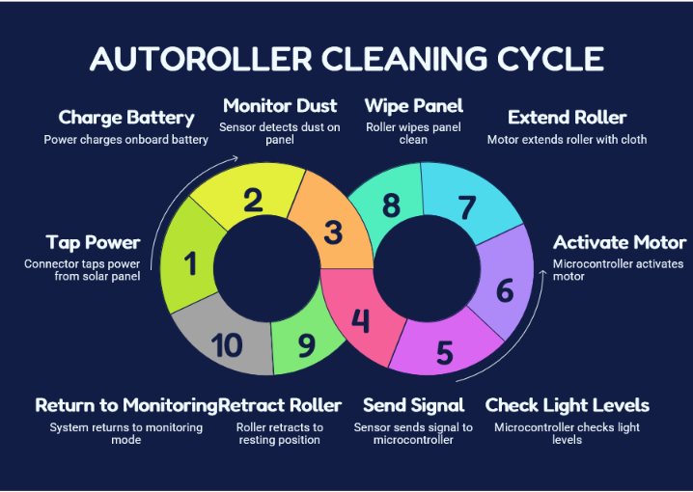
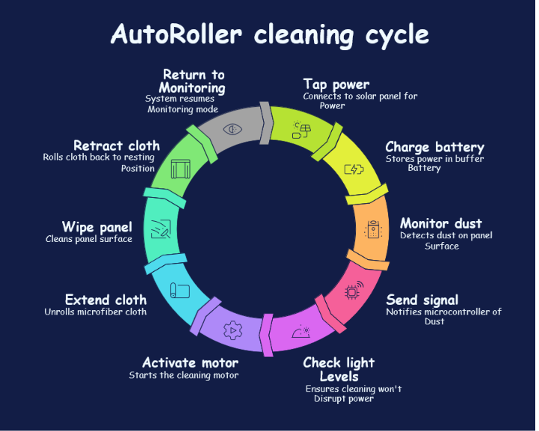

Dated this _____ day of __________, 2026.
Signature: _______________________
Name of Applicant…….et.al

